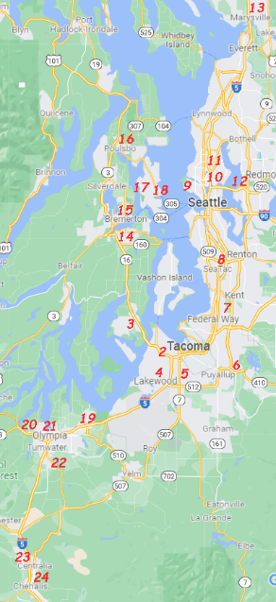

❖ Superior Saw & Supply
2712 Pacific Ave. Tacoma, WA
2. Gray Lumber Co. – 253-752-700 Tue+Fri
3800 6th Ave. Tacoma, WA
3. Ace Hardware (Pt. Fosdick) – 253-858-6169 Wed
4816 Point Fosdick Dr. NW, Gig Harbor, WA
4. Lakewood Hardware – 253-581-1010 Mon
9020 Lakewood Dr. SW, Lakewood, WA
5. Ace Hardware (Parkland) – 253-302-3624 OnCall Mon
105 S 112th St. Parkland, WA
6. Sumner Woodworker Store – 253-891-9413 Tue+Fri
908 Cherry Ave. Sumner, WA
7. Points Sharp Steel – 1-800-249-3758 Mon+Thu
1320 26th St NW Ste#11, Auburn, WA
8. Rockler Woodworking #15 – 206-244-9161 OnCall Tue
345 Tukwila Pkwy. Tukwila, WA
9. Limback Lumber – 206-782-3487 Fri
2600 NW Market St. Seattle, WA
10. Ace Hardware (Maple Leaf) – 206-522-3324 Fri
9000 Roosevelt Way NE, Seattle, WA
11. Rockler Woodworking #2 – 206-634-3222 Fri
832 NE Northgate Way, Seattle, WA
12. R+R Rentals (Bellevue) – 425-888-1111 OnCall Wed
10920 Northup Way Bellevue, WA
13. Central Welding (Smokey Point) – 360-651-2307 Wed
13300 38th Ave NE Marysville, WA
14. Peninsula Feed & Power Equip. – 360-876-8711 Wed
901 Bay St. Port Orchard, WA
15. Kitsap Lumber – 360-479-4414 Wed
450 National Ave. S. Bremerton, WA
16. Coast Hardware DO IT Best – 360-779-2000 Wed
19472 7th Ave NE, Poulsbo, WA
17. Bainbridge Rental – 206-842-3303 Wed
Miller Rd. NE, Bainbridge Isle, WA
18. Builder’s 1st Source (Bainbridge) – 206-842-5691 Wed
10060 NE High School Rd. Bainbridge Isle, WA
19. Bayview Building Materials – 360-943-3050 Mon
3520 Martin Way E. Olympia, WA
20. Lew Rents West – 360-357-3314 Mon
405 McPhee Rd. SW Olympia, WA
21. Hardel Builders Center – 360-357-6353 Mon
2321 Harrison Ave. N. Olympia, WA
22. Tumwater Tool Repair - 360-753-4875 Thur
7840 Old Hwy 99 SE #82 Tumwater, WA
23. ‎ Lincoln Creek Ace Hardware – 360-736-8261 OnCall Thur
1621 Harrison Ave. Centralia, WA
24. Palmer Lumber Co– 360-748-8848 Thur
370 NW State Ave. Chehalis, WA

